Certificate of Origin

The undersigned Absolute Accuracy Inc _
(Owner of Agent)

2451 Riverside Drive Los Angeles California 90039 _
(Name and Address of Shipper)

declares that the following mentioned goods shipped on DHL _ on the date OCty 23, 2014

consigned to: Pakistan Oilfields Ltd. are the product of USA.

Marks and Numbers | No. of Pkgs, Boxes  or Cases | Weight in Kilos | Description
Marks and Numbers | No. of Pkgs, Boxes  or Cases | Gross | Description
Bill of Lading/Air Waybill No.:  DHL | 1 | 9.Kg | Absolute Accuracy  Model 3100  Chart Integrator  HS Code:  9026. 2000

Sworn to before me
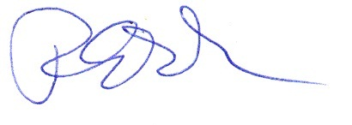
This 23nd _day of Oct_ 20 14_ _________________________
Signature of Owner Agent
Robert Poplar, General Manager

